**CHAWTECH SOLUTIONS PVT LTD**

**STRATEGIC PROPOSITION FOR**

**BUSINESS LISTING PLATFORM DEVELOPMENT**

**(Website and Mobile Apps – IOS & Android)**



A Business Proposal

|  |  |
| --- | --- |
| **Developed For:** | **Carlos Evora** |

**Designed By:** ChawTech Solutions Private Limited

PPC PROPOSAL

|  |  |
| --- | --- |
| To,  **Mr. Carlos Evora** | **Date: February 27, 2020** |

**PPC PROPOSAL:**

1. **Competitor’s Analysis**
2. **Keywords Research Analysis**
3. **Structure and organize your PPC keywords**
4. **Include negative keywords**
5. **Campaign page creation**
6. **Landing page**

the undersigned.

Thanking You,

Yours Sincerely

**Mr. Amit Chawla**

**Sales Head**

**Email – amit@chawtechsolutions.com**

**Skype – anshmahi1**

**Phone – +91 98960 25632**

**CHAWTECH SOLUTIONS PRIVATE LIMITED**

**ABOUT CHAWTECH SOLUTIONS**

ChawTech Solutions Pvt. Ltd is a determined IT consultancy headquarters based in India. Simply put, we bring to your business, immense growth prospects by making your presence felt on this sprawling marketing medium of internet. We first analyze the nature of your business and what exactly you are looking for. Then we decide the medium through which we can transform your business into a money-making entity. Whether it is designing a website, developing an application, redesigning of the existing website, content management or search engine optimization & submission, we have the provision of it all. Leveraging on our adroit professionals with an out of the box thinking temperament and latest technologies, our Internet marketing agency in India has all what it takes to deliver you nothing but the best.

***Our Mission***

Our mission is to touch the horizon where our capabilities may successfully meet with the requirements of our clients, that too with ultimate transparency and cost effectiveness.

***Our Vision***

To sow the seeds of par-excellence services with customer centric approach and reap the trust of worldwide clients.

***Core Values***

* **Transpicuous Work Culture –** Our words and actions always go hand-in-hand. We strongly preserve transparency to be correct ethically, legally and socially as well.
* **Result-Orientation –** By setting clear goals, fixing the priorities, organizing the resources-and rigorously monitoring the growth of project.
* **Customer-Centric Approach –** We revere the uniqueness of each client and his requirements and budget thus shape out the mirror-like solutions.
* **Innovation –** Think and do out of the box by setting the minds free. We also seek the unrevealed possibilities, hidden in feedbacks and suggestions of clients and co-workers.

**CHAWTECH SERVICES**

ChawTech Solutions Pvt. Ltd, offers a complete range of services pertaining to your web presence, from conceptualization till escorting you to the destination. The experience and expertise we have earned are not just matters of years passed rather they have nurtured our understanding of our client’s requirements.

Our zealous group of astute tech-savvies and the state-of-the-art infrastructure always set in mode of action to bring up the best possible web solutions. All these amalgamated with our customer-caring approach have generated a never-ending bond of trust between us and our clients. Our invincible expertise in rendering the services as per the clients’ requirements sets us apart from the rest. Delivering the mirror-like solutions for your imagination in the domain of e-business, we are driven by the mantra of “what you want is what we can”.

Our workforce is packed with highly skilled web designers, developers, copy writers, and SEO experts. This package assures you for hundred percent satisfactions. Approach towards meet the needs of the clients in a focused manner and adherence to the timely delivery of services has given us an edge over our peers in the market. Incessant investment in high-end technologies, human resources and for enhancement of the skills has accounted for higher returns for our clients backed up by integrity and security.

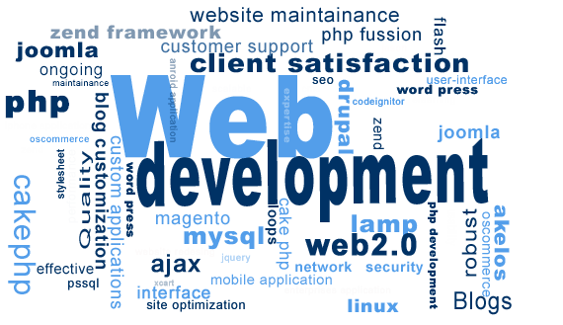

***How These Services Help You ?***

* Offer various modes to **emerge and get promoted in E-Business World**.
* Provide you an **appealing web presence**.
* Entertain your client **24X7**.
* Enable you to **snatch full potential from E-Business World**.
* Bless you with **ever-flourishing online business promotion.**
* Give you opportunities to **expose your business to online** crowd.
* Offer **Global Visibility** in less than the fare of air ticket to one country.
* Assist you to **increase on ROI**.
* Tune-in with **Hi-Technology** and make your stand far ahead from your competitors.
* **Gear-up your business** activities and turn them faster and smoother.

***How We Work – The Methodology***

ChawTech Solutions Pvt. Ltd technical team takes necessary steps to understand customer requirements, and then tailor complete solutions that deliver tangible value to the enterprise. The entire process involves listening customer ideas, delving into their concerns, and considering every aspect of the problem - from the underlying business processes to the importance of change management to the merits of various technologies. ChawTech Solutions Pvt. Ltd technical team then craft unique information systems that move your business forward and yield a measurable return on investment.

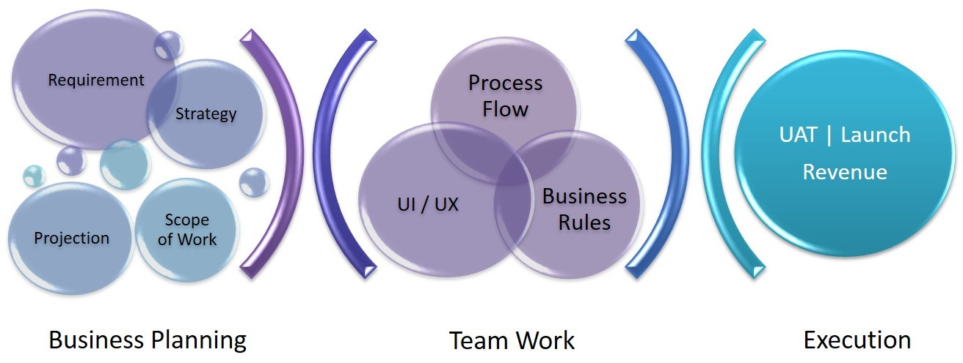

**CHAWTECH PRECIOUS CLIENTS**



**PROPOSED MODULES FOR WEBSITE AND MOBILE APPS**

***Overview***

The Business Listing is a Listing & Searching system that is designed for the two types of users, one who wants to list their businesses on the platform and other who will search the business by applying multiple filters like name, category, zipcode, nearby etc. For listing the business, users will pay certain amount of subscription fee which would be recurring on Monthly or Yearly basis.

**The Business Listing System**

The system has 2 types users i.e. Client (Customer) and an Admin. They all have different roles and responsibilities, as follows

1. **Client/Customers App:** They would be able to access the following modules.
2. **Explore**
   1. **Art & Entertainment, Restaurant, Lodging , Outdoors**
      1. **Images**
      2. **Logo**
      3. **Ratings**
      4. **Reviews**
      5. **Add to favorite**
      6. **Opening Hours**
      7. **Embedded videos from YouTube**
      8. **Claim Profile**
      9. **Contact**
      10. **Social Profile**
      11. **Share Profile**
3. **Learn**
   1. **How it works**
   2. **Pricing Plans**
   3. **Deals & Coupons**
      1. **Best Deals and coupons**
      2. **Add to Cart**
      3. **Checkout cart**
      4. **Apply coupon**
4. **Blogs**
5. **Notifications**
6. **Login**
7. **Forgot Password**
8. **Sign Up**
9. **Verification**
10. **Search**
    1. **Filters**
    2. **Sort**
11. **Contact Us**
12. **Static Contents**
13. **Listing Management**
    1. **Create/Edit/Delete/View**
14. **Subscription**
15. **Payments**
16. **Blogs**
    1. **View/Add/Edit/Delete comments**
17. **Account**
    1. **My Account**
    2. **My Listings**
    3. **Add New Listings**
    4. **Favorites**
    5. **Edit Profile**
    6. **Logout**
18. **Admin :** Admin can do the following things
19. **Login**
20. **Forgot Password**
21. **Profile**
22. **Change Password**
23. **Dashboard**
    1. **Filters**
24. **User Management**
25. **Listing Management**
26. **Deals Management**
27. **Coupon Management**
28. **Categories Management**
29. **Subscription Management**
30. **Payment Summary**
31. **CMS Management**
32. **Send/Receive Notifications**
33. **Settings**
34. **Logout**

***Technical Specifications Includes***

Being a reputed development company, we have been working close with similar services from some time now. Our team follows the latest trends library updated with latest features. This helps us offer custom app solutions with ease.

We offer customized development solutions. We make sure that you face no tough time handling your customers and managing the services of your business. We offer you the most convenient and conventional ways to take the enquiries to your business needs.

* Professionally Designed Layouts: We will use the template

<https://listify-demos.astoundify.com/classic/>

* Platform/CMS:
  + **Back-end:** WordPress CMS
  + **Database:** MySQL
  + **Applications:** Android & IOS
* Technology Used:
  + **Back-end:** PHP
  + **Applications:** Android (Java) & IOS (Swift)
* Operating System: Linux Based

***Proposed Timeline for Modules Development***

|  |  |
| --- | --- |
| **WORK DESCRIPTION** | **DEVELOPMENT TIME FRAME** |
| Website Development | 30 days |
| Backend Development with APIs for Web & Apps | 35 days |
| Android App Development | 35 days |
| IOS App Development | 35 days |
| Application Screen Designs | 12 days |

***Payment Terms***

**Total Cost:** US $10,500

|  |  |
| --- | --- |
| **WORK DESCRIPTION** | **COST** |
| 1st Payment – Upfront (25% of the total cost to allocate resources) | US $2625 |
| 2nd Payment – After integrating the WordPress Template and Designing App Screens (25% of total cost) | US $2625 |
| 3rd Payment – After completion of Back-End (30% of the total cost) | US $3150 |
| 4th Payment – After completion of Android & IOS Apps (20% of the total cost) | US $2100 |

|  |  |
| --- | --- |
| **[Disclosing Party]** | **[Receiving Party]** |
| **By: CHAWTECH SOLUTIONS PVT LTD** | **By: Genesis System** |
| Name: Mr. Amit Chawla | Name: Carlos Evora |
| Sales Head | Software Developer |
| Address: D-171, Sec-63, Noida (India)    Date: February 27, 2020 | Address: 13727 sw 152 street suite 304  Miami Fl 33177  Date: February 27, 2020 |
|  |  |

